**CURRICULUM VITAE**

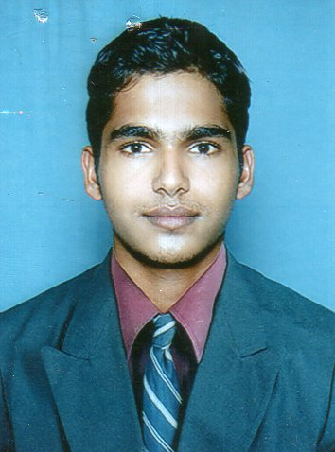

Name : **Harshith Suvarna R.**

Address : “SARVADHA”, Hiriadka, Udupi-576113

Email : suvarnaharshith@gmail.com

Mobile : +91 8050112996

**CARRIER OBJECTIVE:**

A position that will utilize my experience in the service industry while providing a prospect for absolute expose, challenge, professional development with a motivating and creative environment .

**EDUCATIONAL QUALIFICATION:**

|  |  |  |  |
| --- | --- | --- | --- |
| **Degree** | **Institute** | **Year of passing** | **Marks in %** |
| S.S.L.C. | Govt. High School, Hiriadka | 2008 | 70% |
| P.U.C. | Govt. Pre-University Hiriadka | 2010 | 74% |
| B.Com. | MPMC, Manipal | 2013 | 60% |

Date of Birth : 29/03/1993

Father’s Name : H. Ravi Suvarna

Nationality : Indian

Religion : Hindu

Sex : Male

Marital Status : Single

Language Known : English, Kannada, Hindi, Tulu.

**WORK EXPERIENCE IN Axis Bank Ltd. (August 2, 2013 to till now):**

* Worked as Business Development Executive
* Sales in Liability Products

**DECLARATION :**

I declare that the above mentioned statements are true and correct to the best of my knowledge. If I am selected I will discharge my duties for the progress of the company.

**(Harshith Suvarna R.)**

Place: Hiriadka, Udupi

Date: